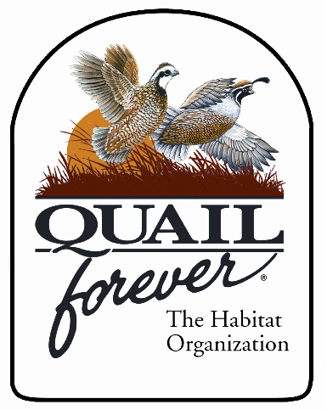

3104 Stoneridge Drive
Edgewood, KY 41017
(859)-393-0605
NKYQuailForever@yahoo.com

Northern Kentucky Quail Forever
Chapter # 3198

Learn to Hunt Event #2
at
Turkey Ridge Hunt Club

Event Date: Saturday, March 26, 2016, 7:00 AM to 1:00 pm
Place: Turkey Ridge, 4427 Lizmark Ln. , Burlington, KY 41055
Contact: Mike Coyle 859-393-0605

Members and Supporters,

The Northern Kentucky Quail Forever Chapter will be sponsoring our second annual youth quail hunt. This will be a chance to hunt released quail for youths ages 12-17 with little to no experience hunting birds. Trap shooting experience would be a plus but not required. Due to time and resources, this event will be limited to twelve hunters only.
Application deadline is Saturday March 12th , 2016.
Applications will be accepted by email, mail or phone. The participants will be selected by random draw from all that apply. Winners will be notified by March 19, 2015. Birds, dogs, guides, guns, and shells will be provided.

Each hunter will undergo a short safety seminar prior to hunting.
There will be a Quail Forever mentor accompanying each hunter.
Hunters will be encouraged to help clean their own birds, and take home what they shoot.
Parents can follow and watch, but may not carry a gun.

Requirements:
Each hunter must have a valid State Hunter Education Card
Each hunter will need a 2016 Kentucky hunting license
Each hunter will need a waiver signed by a parent
$30 bird fee per hunter (payment due only if drawn to hunt)

Hunter’s name: _____________________________ Age: _____________________
Address: _____________________________________________________________
Telephone:_________________________ E-mail: ___________________________
Hunter Education Certificate Number:______________________________________

